**Ganpat University**

**Faculty of Engineering & Technology**

**Computer Science & Engineering**

**Practical_4**

***Name:- Dwij Vatsal Desai***

***Sem:- 3***

***Sub: - DBMS­­***

***Enrollment No.:- 23162121027***

1. **Table Name: Client_master**

Description: Used to store information about clients.

|  |  |  |  |
| --- | --- | --- | --- |
| **Column Name** | **Data Type** | **Size** | **Attributes** |
| Client_no | Varchar | 6 | Primary key/ first letter  must start with ‘C’ |
| Name | Varchar | 15 | Not Null |
| City | Varchar | 15 |  |
| Pincode | Numeric | 8 |  |
| State | Varchar | 15 |  |
| Bal_due | Numeric | 10,2 |  |

|  |  |  |  |  |  |
| --- | --- | --- | --- | --- | --- |
| **Client_no** | **Name** | **City** | **Pincode** | **State** | **Bal_due** |
| C001 | Ivan | Bombay | 400054 | Maharashtra | 15000 |
| C002 | Vandana | Madras | 780001 | Tamil Nadu | 0 |
| C003 | Pramada | Bombay | 400057 | Maharashtra | 5000 |
| C004 | Basu | Bombay | 400056 | Maharashtra | 0 |
| C005 | Ravi | Delhi | 100001 | Gujarat | 2000 |
| C006 | Rukmani | Bombay | 400050 | Maharashtra | 0 |

1. **Table Name: Product_master**

Description: Used to store information about products.

|  |  |  |  |
| --- | --- | --- | --- |
| **Column Name** | **Data Type** | **Size** | **Attributes** |
| Product_no | Varchar | 6 | Primary key/ first letter  must start with ‘P’ |
| Description | Varchar | 15 | Not Null |
| P_percent | Numeric | 4,2 | Not Null |
| U_measure | Varchar | 10 | Not Null |
| Qty_on_hand | Numeric | 8 | Not Null |
| Reorder_lvl | Numeric | 8 | Not Null |
| Sell_price | Numeric | 8,2 | Not Null, cannot be 0 |
| Cost_price | Numeric | 8,2 | Not Null, cannot be 0 |

|  |  |  |  |  |  |  |  |
| --- | --- | --- | --- | --- | --- | --- | --- |
| Product_  No | Description | P_  Percent | U_  Measure | Qty_on_  hand | Reorder_  Lvl | sell_  price | Cost_  Price |
| P001 | Floppies | 5 | Piece | 100 | 20 | 525 | 500 |
| P002 | Monitor | 6 | Piece | 10 | 3 | 12000 | 11280 |
| P003 | Mouse | 5 | Piece | 20 | 5 | 1050 | 1000 |
| P004 | Floppies | 5 | Piece | 100 | 20 | 525 | 500 |
| P005 | Keyboards | 2 | Piece | 10 | 3 | 3150 | 3050 |
| P006 | Cd Drive | 2.5 | Piece | 10 | 3 | 5250 | 5100 |
| P007 | 1.44 Drive | 4 | Piece | 10 | 3 | 8400 | 8000 |

1. **Table Name: Salesman_master**

Description: Used to store information about salesman working in the company.

|  |  |  |  |
| --- | --- | --- | --- |
| **Column Name** | **Data Type** | **Size** | **Attributes** |
| S_no | Varchar | 6 | Primary key/ first letter  must start with ‘S’ |
| S_name | Varchar | 15 | Not Null |
| City | Varchar | 10 |  |
| Pincode | Numeric | 8 |  |
| State | Varchar | 12 |  |
| Sal_amt | Numeric | 8,2 | Not Null, cannot be 0 |
| Tgt_to_get | Numeric | 6,2 | Not Null, cannot be 0 |
| Ytd_sales | Numeric | 6,2 | Not Null |
| Remarks | Varchar | 20 |  |

|  |  |  |  |  |  |  |  |  |
| --- | --- | --- | --- | --- | --- | --- | --- | --- |
| S_no | S_name | City | Pincode | State | Sal_ Amt | Tgt_ to  get | Ytd_ Sales | remarks |
| S001 | Kiran | Bombay | 400002 | Maharashtar | 3000 | 100 | 50 | Excellent |
| S002 | Manish | Bombay | 400001 | Maharashta | 3000 | 200 | 100 | Good |
| S003 | Ravi | Bombay | 400032 | Maharashta | 3000 | 200 | 100 | Average |
| S004 | Ashish | Bombay | 400044 | Maharashta | 3500 | 200 | 150 | Good |

1. **Table Name: Sales_order**

Description: Used to store client’s orders.

|  |  |  |  |
| --- | --- | --- | --- |
| **Column Name** | **Data**  **Type** | **Size** | **Attributes** |
| Order_no | Varchar | 6 | Primary key/ first letter must start with ‘O’ |
| Order_date | Date |  |  |
| Client_no | Varchar | 6 | Foreign key references client_no of client_master  table. |
| S_no | Varchar | 6 | Foreign key references s_no of salesman_master  table. |
| Dely_type | Char | 1 | Delivery: part(P) / full (F) Default ‘F’ |
| Billed_yn | Char | 1 |  |
| Dely_date | Date |  | Cannot be less than order_date |
| Order_status | Varchar | 10 | Values(‘inprocess’,’fullfiled’,’backorder’,’cancelled’) |

|  |  |  |  |  |  |  |  |
| --- | --- | --- | --- | --- | --- | --- | --- |
| Order_no | Order_date | Client_no | S_no | Dely_ type | Billed_yn | Dely_date | Order_status |
| O1901 | 12-Jan-06 | C001 | S001 | F | N | 20-Jan-06 | In Process |
| O1902 | 25-Jan-06 | C002 | S002 | P | N | 27-Jan-06 | Cancelled |
| O4665 | 18-feb-06 | C003 | S003 | F | Y | 20-Feb-06 | Fullfilled |
| O1903 | 03-Apr-06 | C001 | S001 | F | Y | 07-Apr-06 | Fullfield |
| O4666 | 20-May-06 | C004 | S002 | P | N | 22-May-06 | Cancelled |
| O1908 | 24-May-06 | C005 | S003 | F | N | 26-May-06 | In Process |

1. **Table Name: Sales_order_details**

Description: Used to store client’s orders with details of each product ordered.

|  |  |  |  |
| --- | --- | --- | --- |
| **Column Name** | **Data Type** | **Size** | **Attributes** |
| Order_no | Varchar | 6 | Primary Key/ Foreign Key  references order_no of the sales_order table. |
| Product_no | Varchar | 6 | Primary Key/ Foreign Key references product_no of the  Product_master table. |
| Qty_ordered | Numeric | 8 |  |
| Qty_disp | Numeric | 8 |  |
| Product_rate | Numeric | 10,2 |  |

|  |  |  |  |  |
| --- | --- | --- | --- | --- |
| **Order_no** | **Product_no** | **Qty_ordered** | **Qty_disp** | **Product_rate** |
| O1901 | P001 | 4 | 4 | 525 |
| O1901 | P002 | 2 | 1 | 8400 |
| O1901 | P003 | 2 | 1 | 5250 |
| O1902 | P001 | 10 | 0 | 525 |
| O4665 | P002 | 3 | 3 | 3150 |
| O4665 | P004 | 3 | 1 | 5250 |
| O4665 | P005 | 10 | 10 | 525 |
| O4665 | P003 | 4 | 4 | 1050 |
| O1903 | P006 | 2 | 2 | 1050 |
| O1903 | P004 | 1 | 1 | 12000 |
| O1908 | P005 | 1 | 0 | 8400 |
| O1908 | P007 | 10 | 0 | 1050 |

**Exercise:**

Create Above tables with given constraints and insert data in it.

# Solution Query:

1. **Table Created: Client_master**
   * + CREATE TABLE Client_master (

Client_no VARCHAR(6) NOT NULL PRIMARY KEY CHECK

(Client_no LIKE 'C%'),

Name VARCHAR(15) NOT NULL, City VARCHAR(15),

Pincode NUMERIC(8), State VARCHAR(15), Bal_due NUMERIC(10,2)

);

* + - INSERT INTO Client_master (Client_no, Name, City, Pincode, State, Bal_due)

VALUES

('C001', 'Ivan', 'Bombay', 400054, 'Maharashtra', 15000),

('C002', 'Vandana', 'Madras', 780001, 'Tamil Nadu', 0), ('C003', 'Pramada', 'Bombay', 400057, 'Maharashtra', 5000),

('C004', 'Basu', 'Bombay', 400056, 'Maharashtra', 0),

('C005', 'Ravi', 'Delhi', 100001, 'Gujarat', 2000),

('C006', 'Rukmani', 'Bombay', 400050, 'Maharashtra', 0);

* + - SELECT * FROM Client_master;

# Image:

# 

1. **Table Created: Product_master**
   * 1. CREATE TABLE Product_master (

Product_no VARCHAR(6) NOT NULL PRIMARY KEY

CHECK(Product_no LIKE 'P%'), Description VARCHAR(15) NOT NULL, P_percent NUMERIC(4,2) NOT NULL,

U_measure VARCHAR(10) NOT NULL,

Qty_on_hand NUMERIC(8) NOT NULL, Reorder_lvl NUMERIC(8) NOT NULL,

Sell_price NUMERIC(8,2) NOT NULL CHECK (Sell_price != 0), Cost_price NUMERIC(8,2) NOT NULL CHECK (Cost_price != 0)

);

* + 1. INSERT INTO Product_master (Product_no, Description, P_percent, U_measure, Qty_on_hand, Reorder_lvl, Sell_price, Cost_price) VALUES

('P001', 'Floppies', 5, 'Piece', 100, 20, 525, 500),

('P002', 'Monitor', 6, 'Piece', 10, 3, 12000, 11280),

('P003', 'Mouse', 5, 'Piece', 20, 5, 1050, 1000),

('P004', 'Floppies', 5, 'Piece', 100, 20, 525, 500),

('P005', 'Keyboards', 2, 'Piece', 10, 3, 3150, 3050),

('P006', 'Cd Drive', 2.5, 'Piece', 10, 3, 5250, 5100),

('P007', '1.44 Drive', 4, 'Piece', 10, 3, 8400, 8000);

* + 1. SELECT * FROM Product_master;

# Image:

1. **Table Created: Salesman_master**

CREATE TABLE Salesman_master (

S_no VARCHAR(6) NOT NULL PRIMARY KEY CHECK (S_no LIKE 'S%'),

S_name VARCHAR(15) NOT NULL,

City VARCHAR(10),

Pincode NUMERIC(8),

State VARCHAR(12),

Sal_amt NUMERIC(8,2) NOT NULL CHECK (Sal_amt != 0),

Tgt_to_get NUMERIC(6,2) NOT NULL CHECK (Tgt_to_get != 0),

Ytd_sales NUMERIC(6,2) NOT NULL,

Remarks VARCHAR(20)

);

INSERT INTO Salesman_master

(S_no, S_name, City, Pincode, State, Sal_amt, Tgt_to_get, Ytd_sales, Remarks)

VALUES

('S001', 'Kiran', 'Bombay', 400002, 'Maharashtra', 3000, 100, 50, 'Excellent'),

('S002', 'Manish', 'Bombay', 400001, 'Maharashtra', 3000, 200, 100, 'Good'),

('S003', 'Ravi', 'Bombay', 400032, 'Maharashtra', 3000, 200, 100, 'Average'),

('S004', 'Ashish', 'Bombay', 400044, 'Maharashtra', 3500, 200, 150, 'Good');

SELECT * FROM Salesman_master;

# Image:

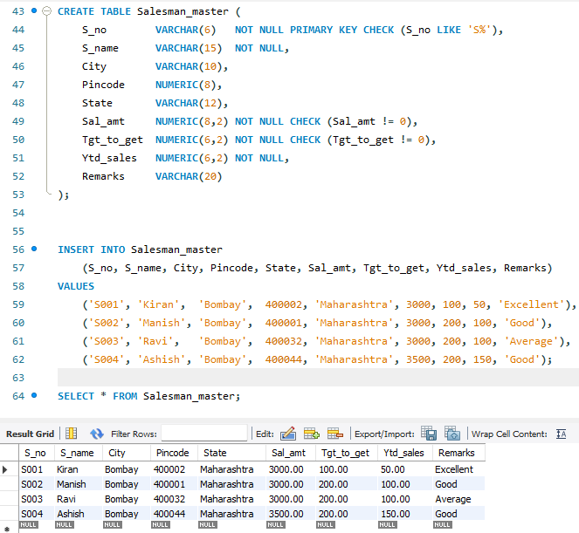

1. **Table Created: Sales_order**

-- Creating the Sales_order table

CREATE TABLE Sales_order (

Order_no VARCHAR(6) PRIMARY KEY CHECK (Order_no LIKE 'O%'),

Order_date DATE,

Client_no VARCHAR(6),

S_no VARCHAR(6),

Dely_type CHAR(1) DEFAULT 'F',

Billed_yn CHAR(1),

Dely_date DATE,

Order_status VARCHAR(10),

FOREIGN KEY (Client_no) REFERENCES Client_master(Client_no),

FOREIGN KEY (S_no) REFERENCES Salesman_master(S_no),

CHECK (Dely_type IN ('P', 'F')),

CHECK (Dely_date >= Order_date),

CHECK (Order_status IN ('inprocess', 'fullfiled', 'backorder', 'cancelled'))

);

INSERT INTO Sales_order

(Order_no, Order_date, Client_no, S_no, Dely_type, Billed_yn, Dely_date, Order_status)

VALUES

('O1901', '2006-01-12', 'C001', 'S001', 'F', 'N', '2006-01-20', 'inprocess'),

('O1902', '2006-01-25', 'C002', 'S002', 'P', 'N', '2006-01-27', 'cancelled'),

('O4665', '2006-02-18', 'C003', 'S003', 'F', 'Y', '2006-02-20', 'fullfiled'),

('O1903', '2006-04-03', 'C001', 'S001', 'F', 'Y', '2006-04-07', 'fullfiled'),

('O4666', '2006-05-20', 'C004', 'S002', 'P', 'N', '2006-05-22', 'cancelled'),

('O1908', '2006-05-24', 'C005', 'S003', 'F', 'N', '2006-05-26', 'inprocess');

SELECT * FROM Sales_order;

# Image:

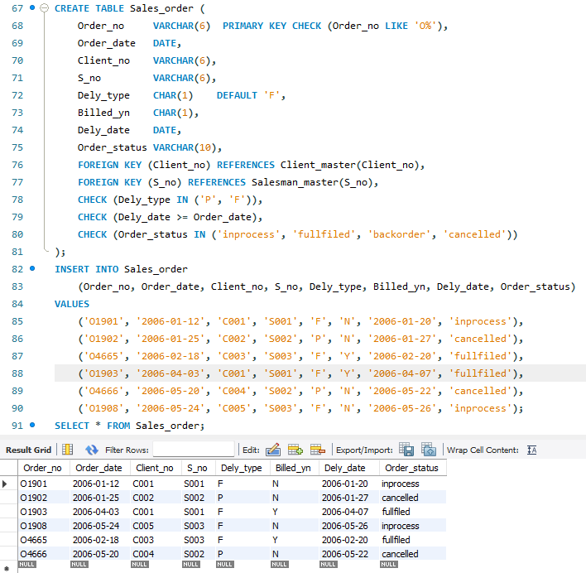

1. **Table Created: Sales_order_details**

-- Creating the Sales_order_details table

CREATE TABLE Sales_order_details (

Order_no VARCHAR(6),

Product_no VARCHAR(6),

Qty_ordered NUMERIC(8),

Qty_disp NUMERIC(8),

Product_rate NUMERIC(10,2),

PRIMARY KEY (Order_no, Product_no),

FOREIGN KEY (Order_no) REFERENCES Sales_order(Order_no),

FOREIGN KEY (Product_no) REFERENCES Product_master(Product_no)

);

INSERT INTO Sales_order_details

(Order_no, Product_no, Qty_ordered, Qty_disp, Product_rate)

VALUES

('O1901', 'P001', 4, 4, 525),

('O1901', 'P002', 2, 1, 8400),

('O1901', 'P003', 2, 1, 5250),

('O1902', 'P001', 10, 0, 525),

('O4665', 'P002', 3, 3, 3150),

('O4665', 'P004', 3, 1, 5250),

('O4665', 'P005', 10, 10, 525),

('O4665', 'P003', 4, 4, 1050),

('O1903', 'P006', 2, 2, 1050),

('O1903', 'P004', 1, 1, 12000),

('O1908', 'P005', 1, 0, 8400),

('O1908', 'P007', 10, 0, 1050);

SELECT * FROM Sales_order_details;

# Image:

